**ANALYSING THE PERFORMANCE AND EFICCIENCY OF RADISSON HOTEL USING DATA VISUALISATION TECHNIQUES**

**1.INTRODUCTION:**

**1.1 OVERVIEW:**

**Radisson owns multiple five-star hotels across India. They have been in the hospitality industry for the**

**past 100 years. Due to strategic moves from other competitors and ineffective decision-making in**

**management, Radisson is losing its market share and revenue in the luxury/business hotels category.**

**As a strategic move, the managing director of Radisson wanted to incorporate Business and Data**

**Intelligence in order to regain their market share and revenue. Our task is to create an analytics**

**dashboard & story to provide them insights to make better business decissions.**

**1.2 PURPOSE:**

**PURPOSE:**

**With the help of Service Guarantee program, a company can add value offer to employees and customers, as well. These types of programs encourage customers to give voice to their complaints so that their queries can be analyzed, solved and promote employees to ensure offering high-quality service to them. Moreover, it will help the firm to find out customers who are dissatisfied with the hotel’s performance and the reason behind their dissatisfaction. Service guarantee will assist Radisson Hotel to find out the impact of service quality on the financial and overall business performance.**

**2.PROBLEM DEFINITION AND DESIGN THINKING:**

**What are the problems in the analysing and performance of Radisson hotel and how to solve it ?**

**2.1EMPATHY MAP:**

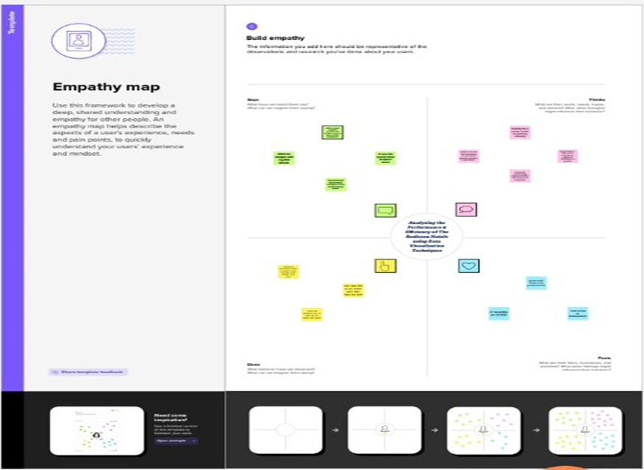

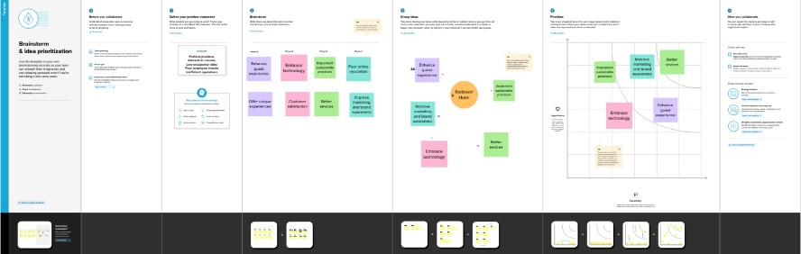**2.2 IDEATION AND BRAINSTORMING MAP:**

**3.RESULT:**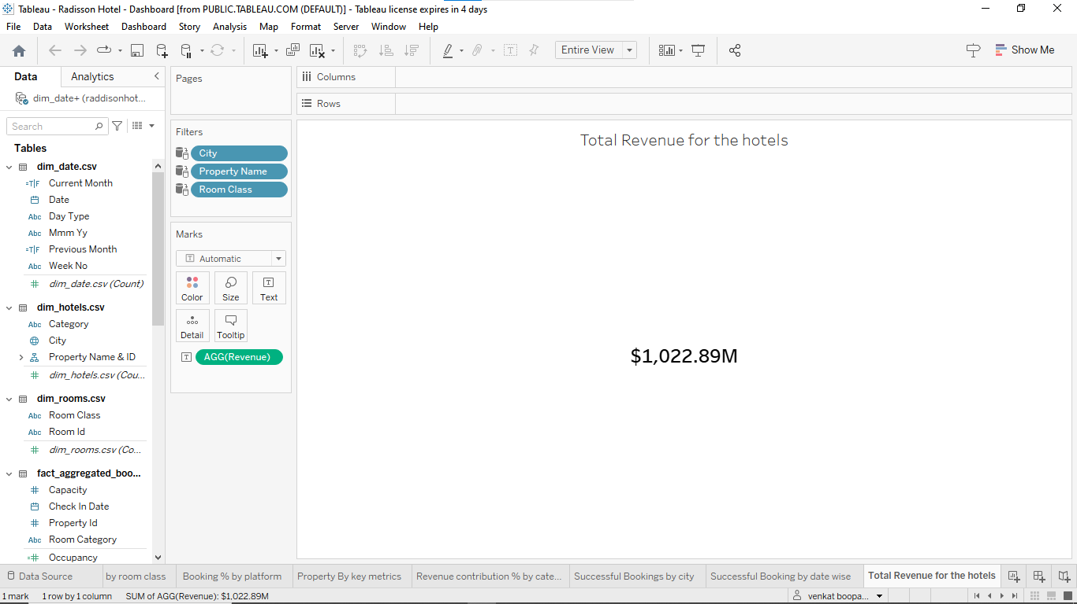

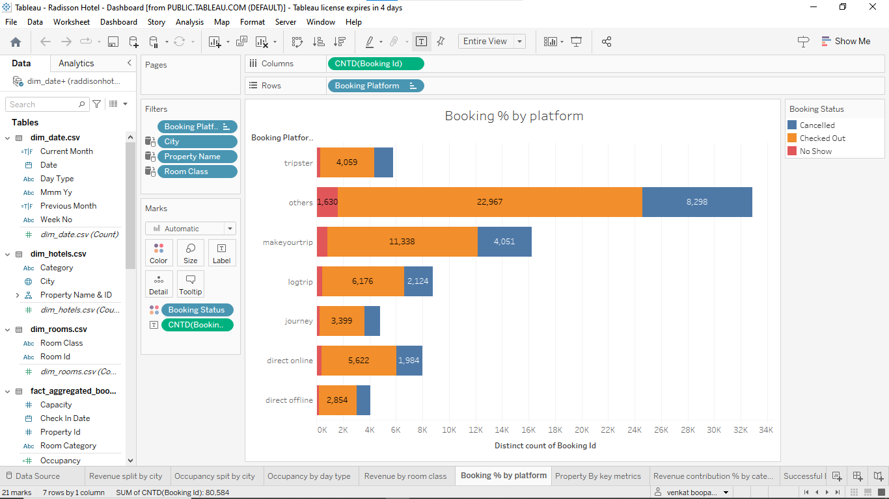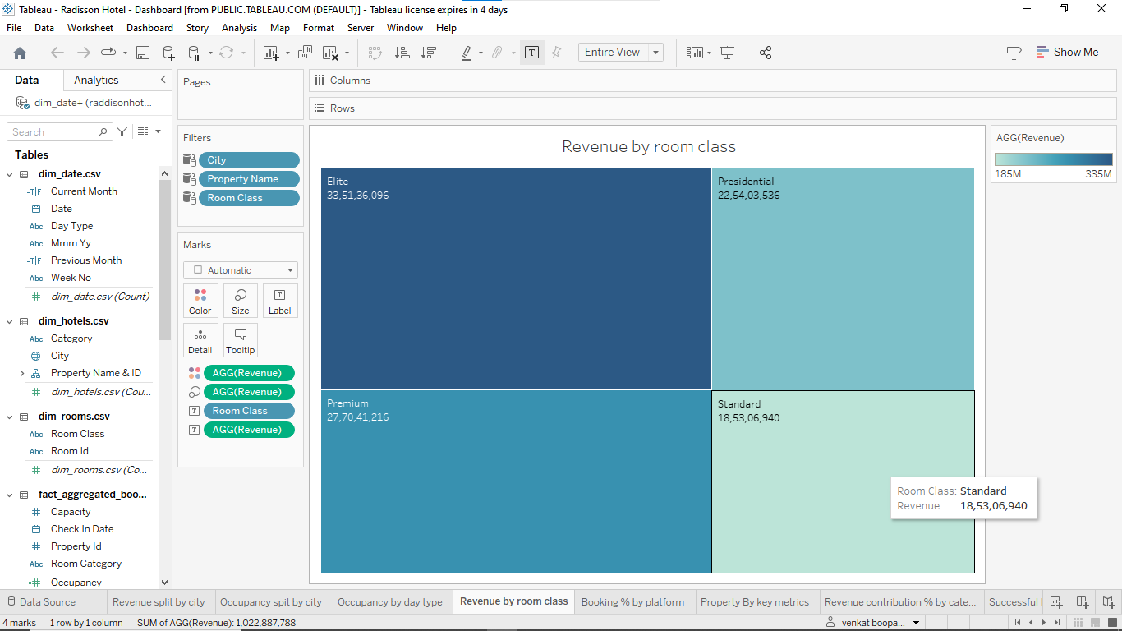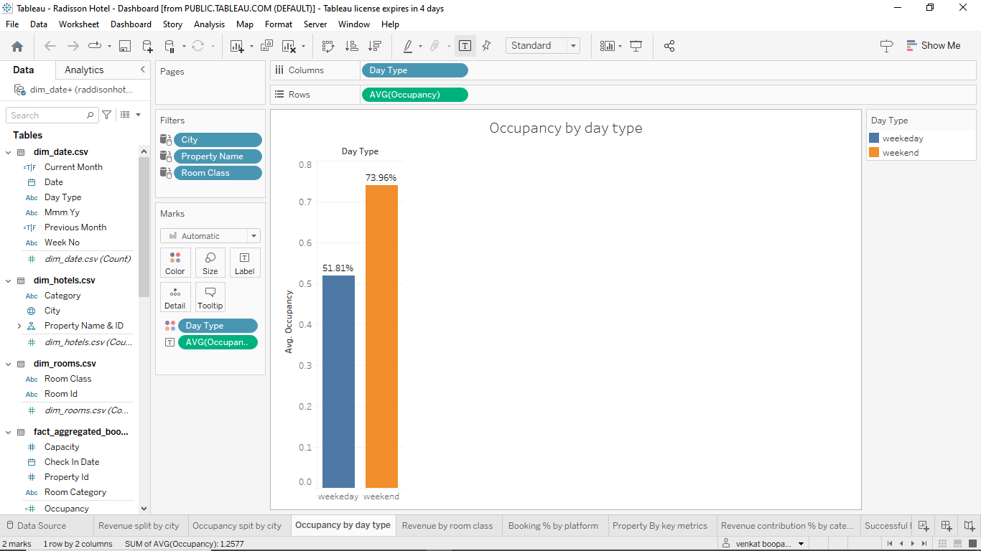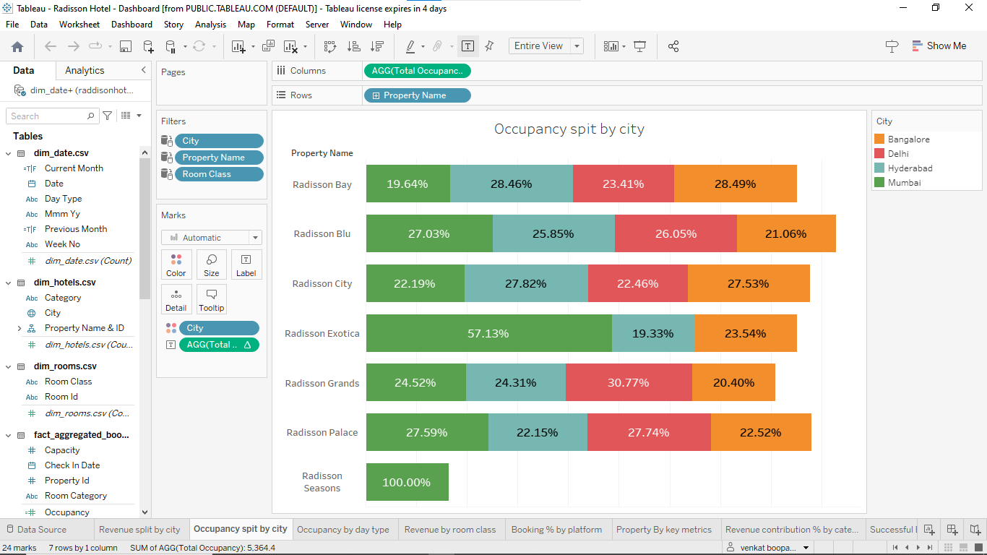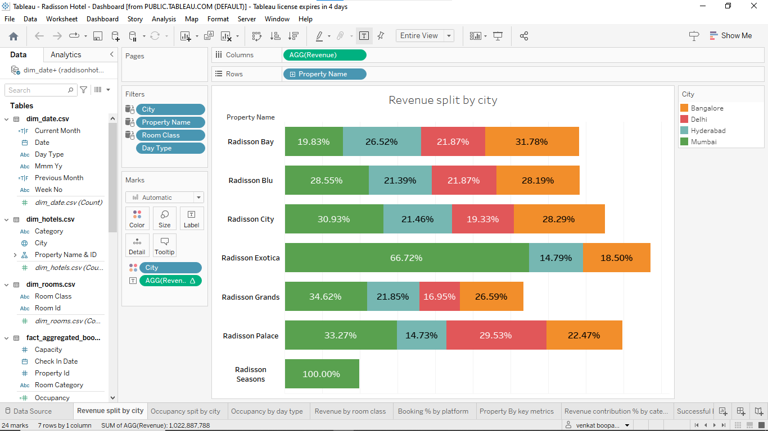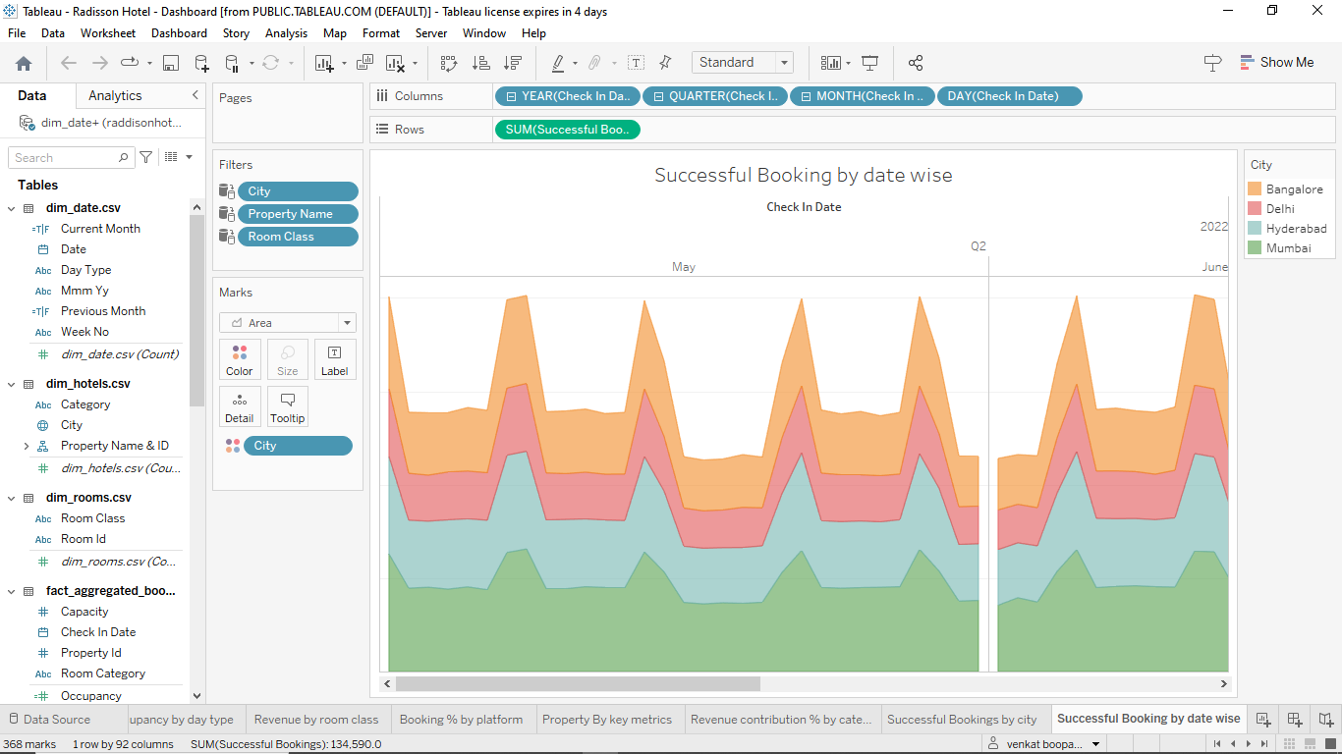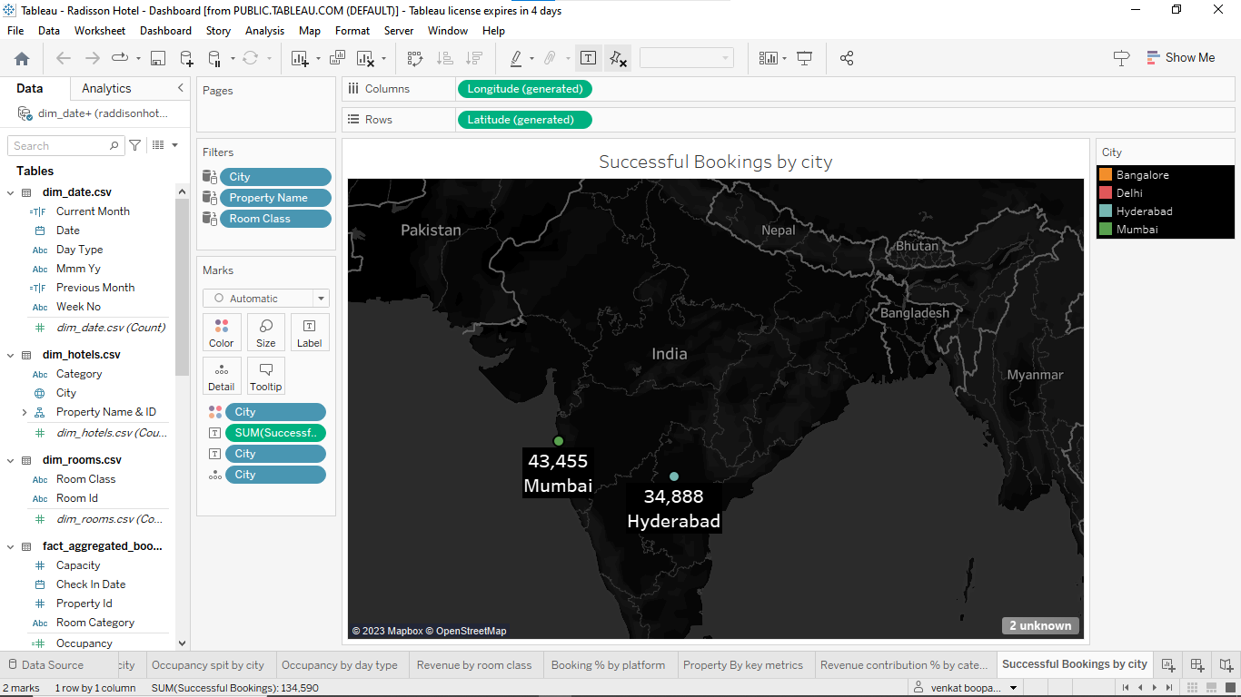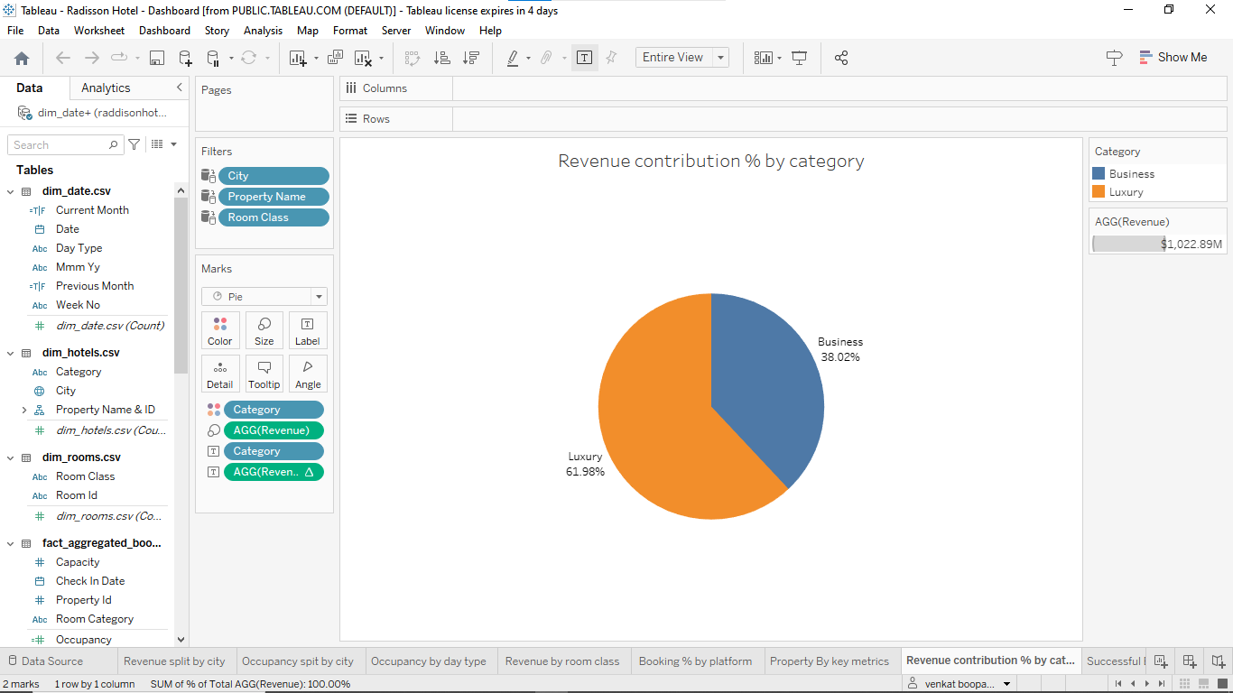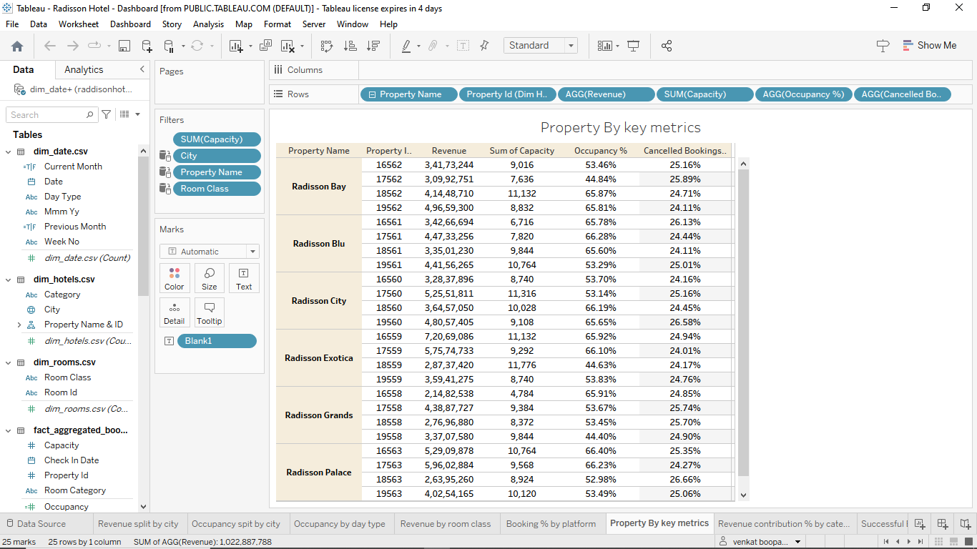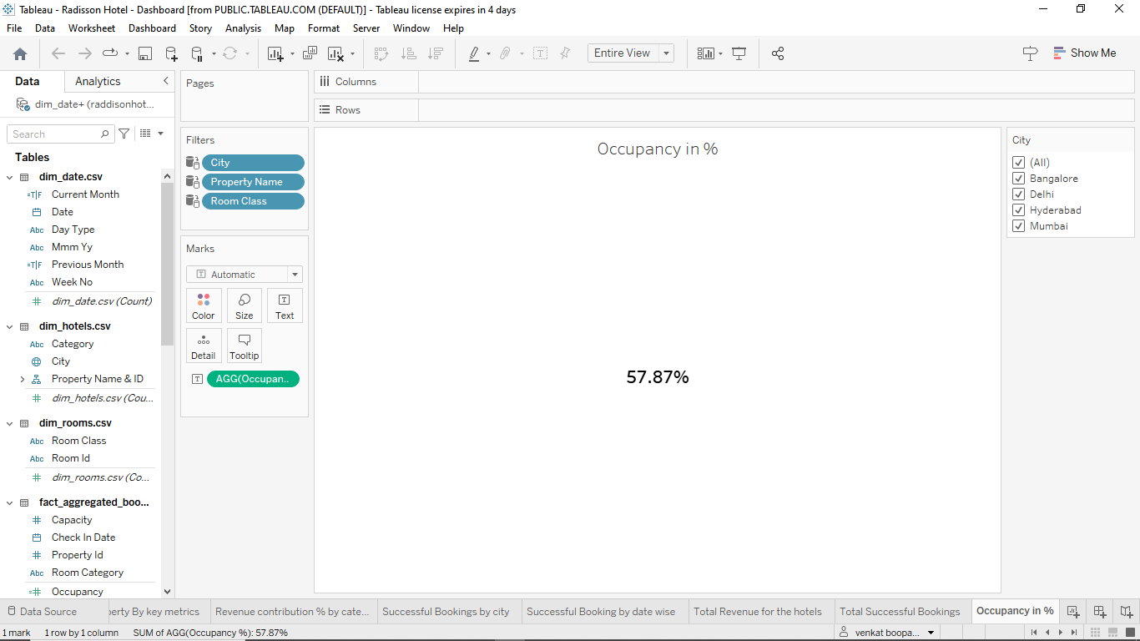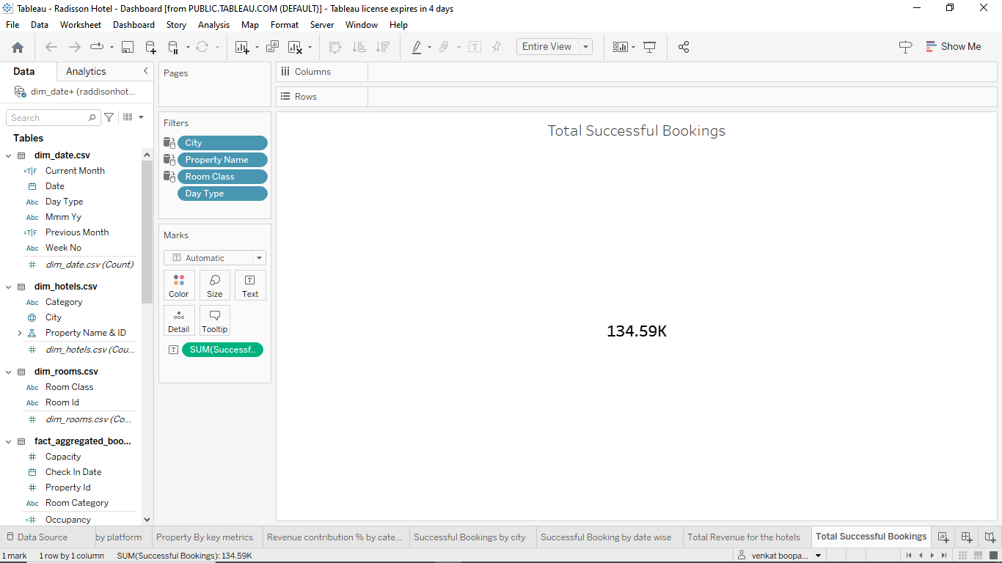

**4. ADVANTAGES AND DISADVANTAGES:**

**ADVANTAGES:**

**The analysis of a Radisson hotel can provide several advantages, including:**

**Identification of strengths and weaknesses: Analyzing the Radisson hotel can help identify its strengths and weaknesses, including its service quality, amenities, and facilities. This information can be used to make informed decisions about how to improve the hotel's offerings.**

**Improved customer satisfaction: By analyzing customer feedback and reviews, the hotel can identify areas that need improvement and take steps to address them. This can lead to increased customer satisfaction and loyalty.**

**Competitive advantage: By understanding the strengths and weaknesses of its competitors, the hotel can develop strategies to differentiate itself and gain a competitive advantage in the market.**

**Better operational efficiency: Analyzing the hotel's operational processes, such as housekeeping and maintenance, can help identify areas for improvement and increase efficiency.**

**Improved financial performance: A thorough analysis of the hotel's financial performance can help identify areas for cost savings and revenue growth. This can lead to improved profitability and financial stability.**

**5.APPLICATION:**

**Enhanced marketing and branding: Analyzing customer behavior and preferences can help the hotel develop targeted marketing campaigns and build a strong brand reputation.**

**Overall, analyzing a Radisson hotel can provide valuable insights that can be used to improve its operations, customer satisfaction, and financial performance.**

**6.CONCLUSION:**

**By analysing the performance and efficiency of Radisson hotel strength and weakness was found . The company can focus in customer satisfaction and employers loyalty.**

**DASHBOARD:** 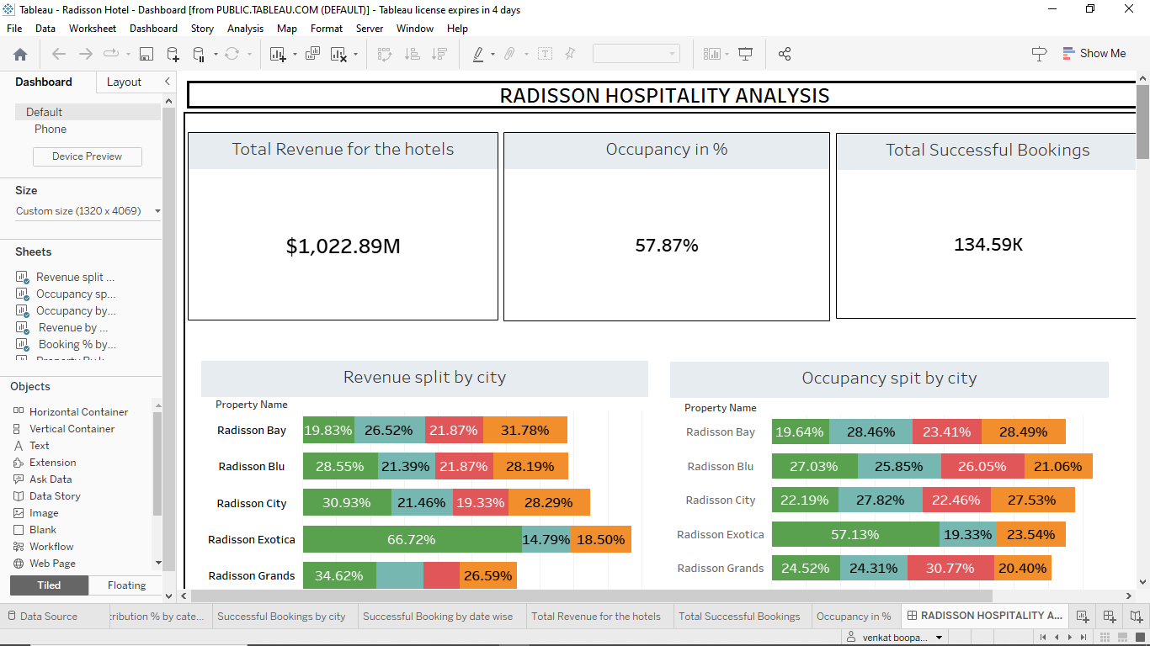

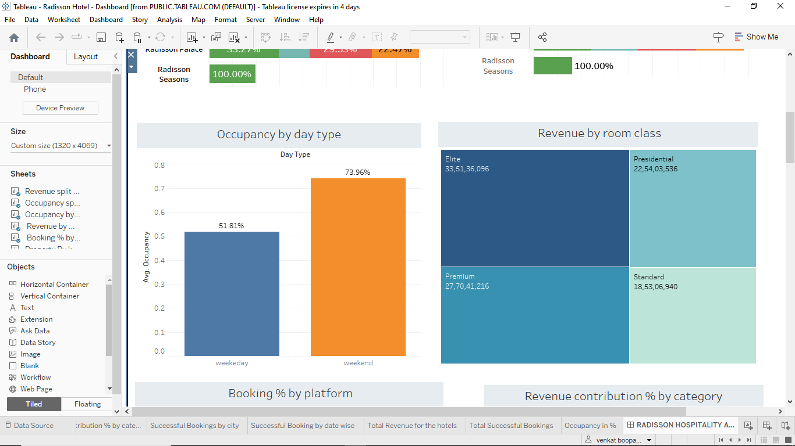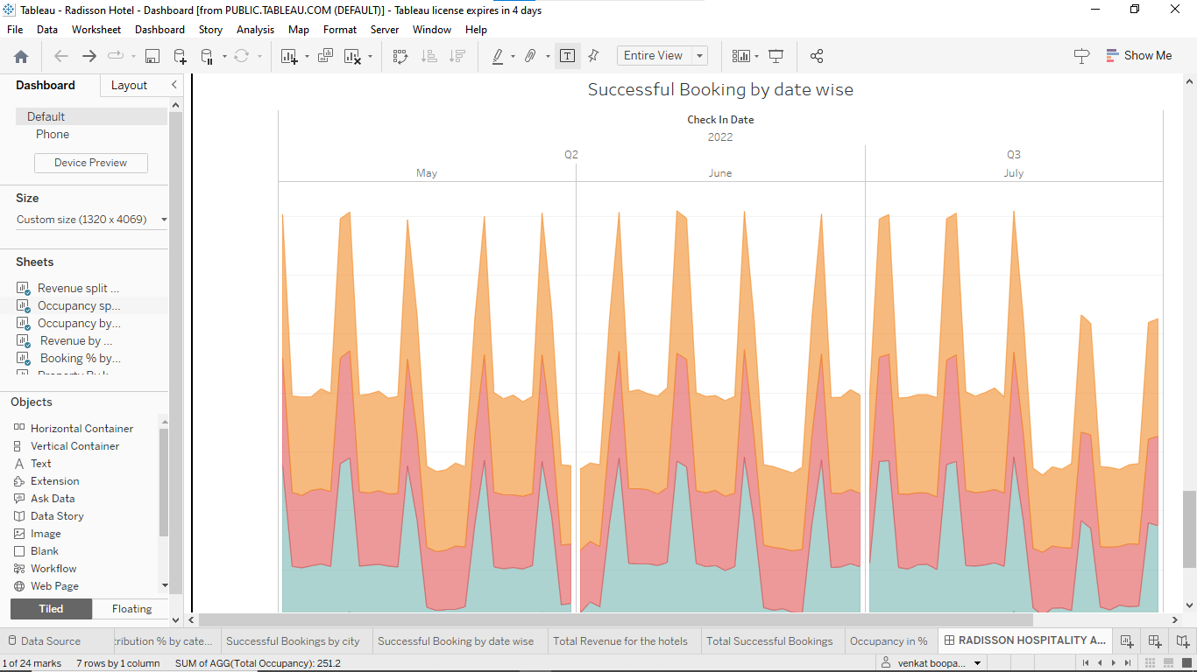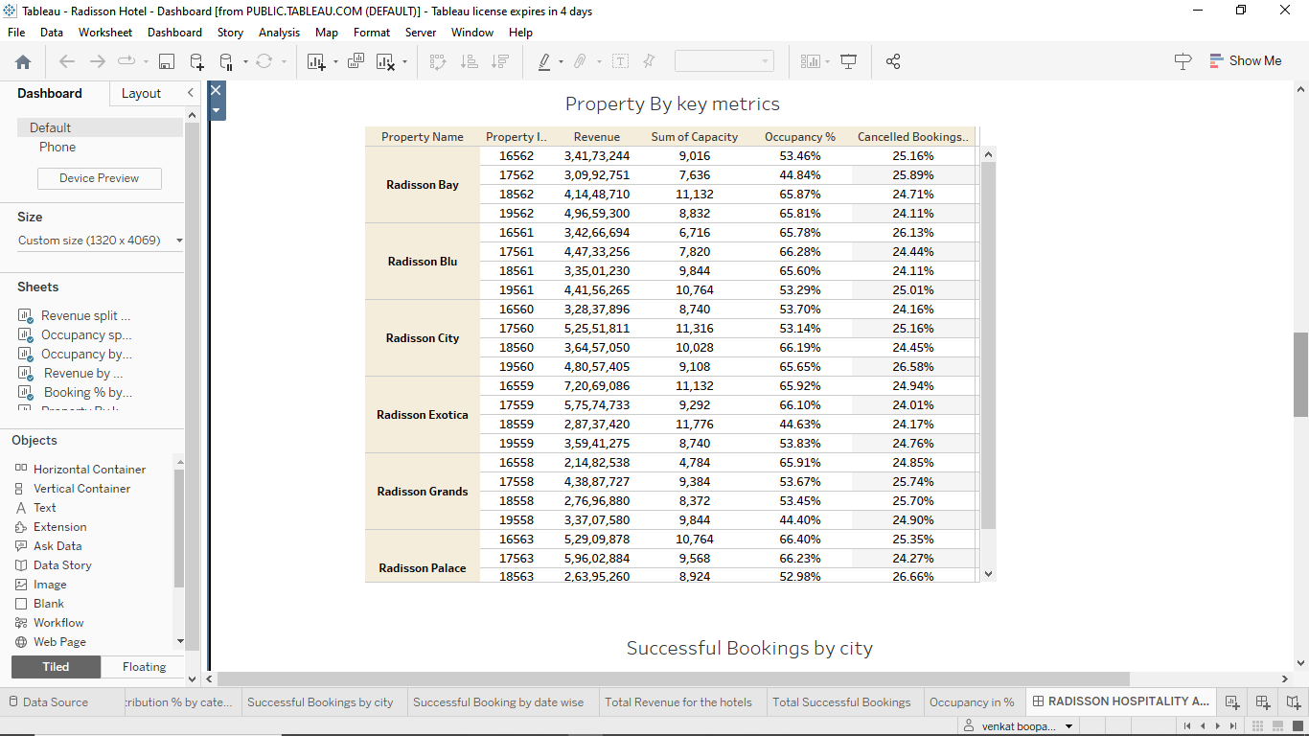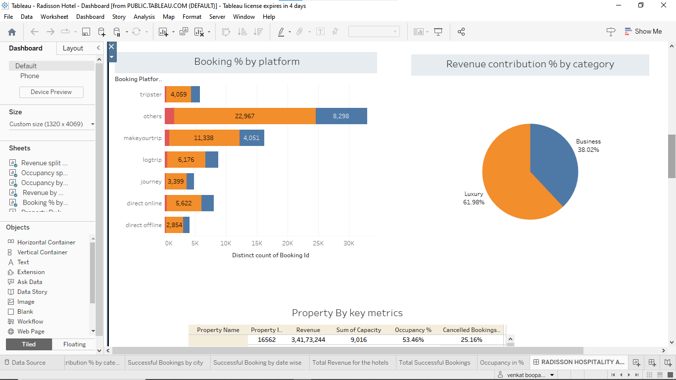

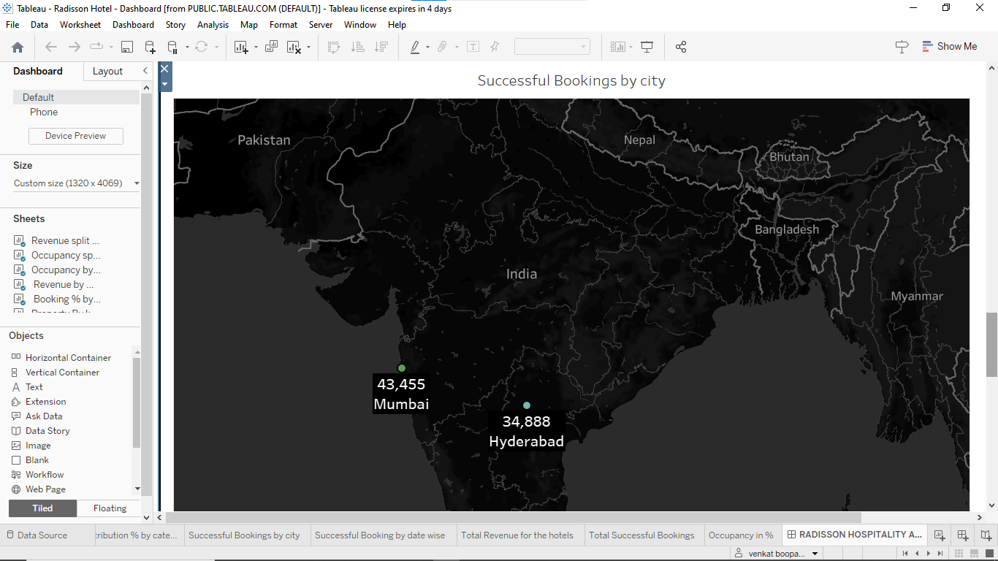

**STORY:** 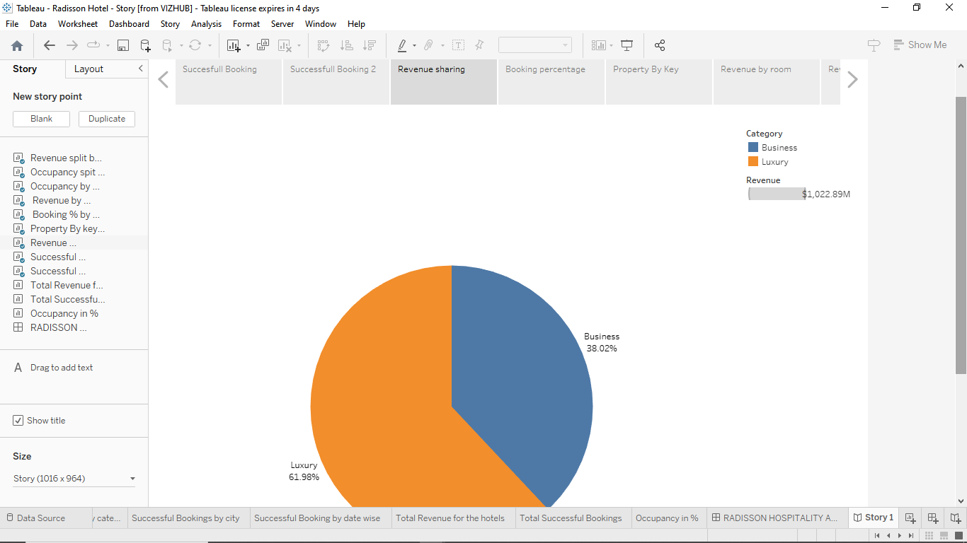

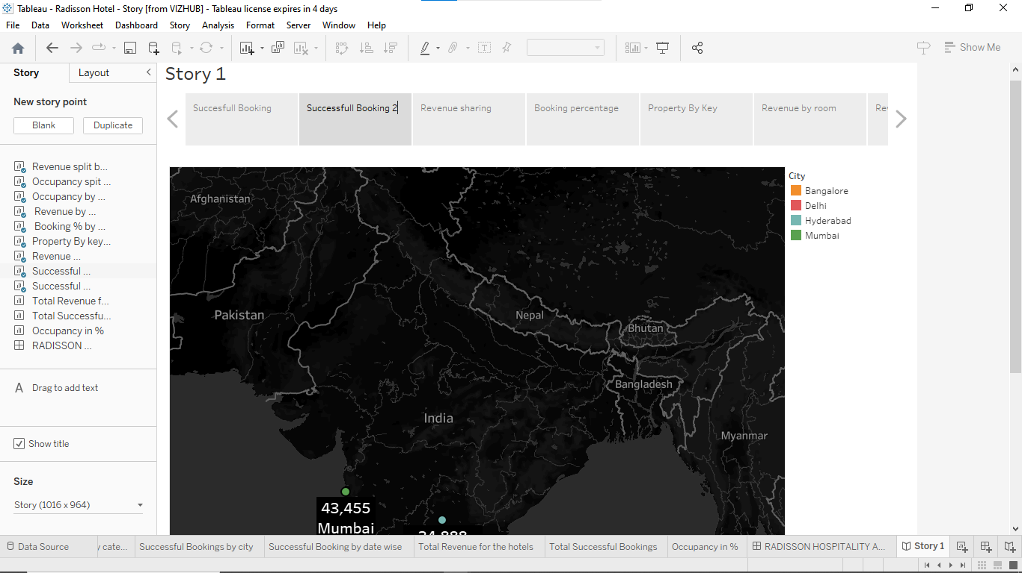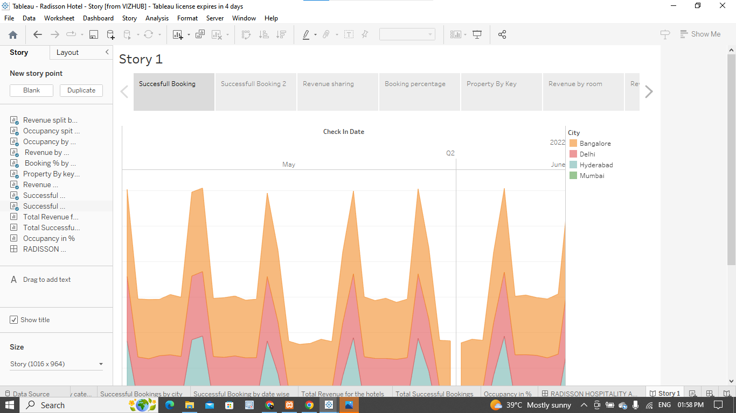

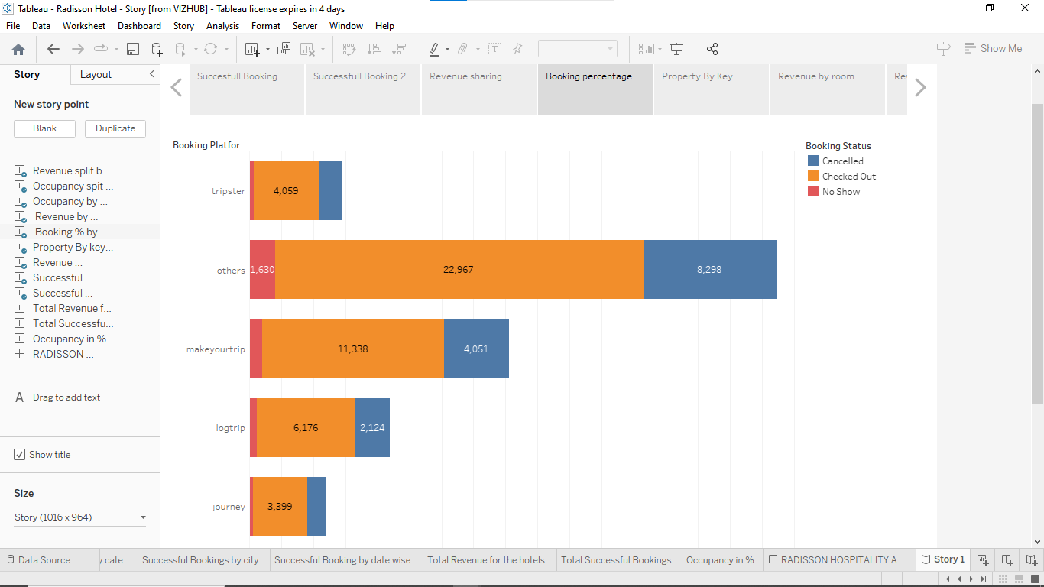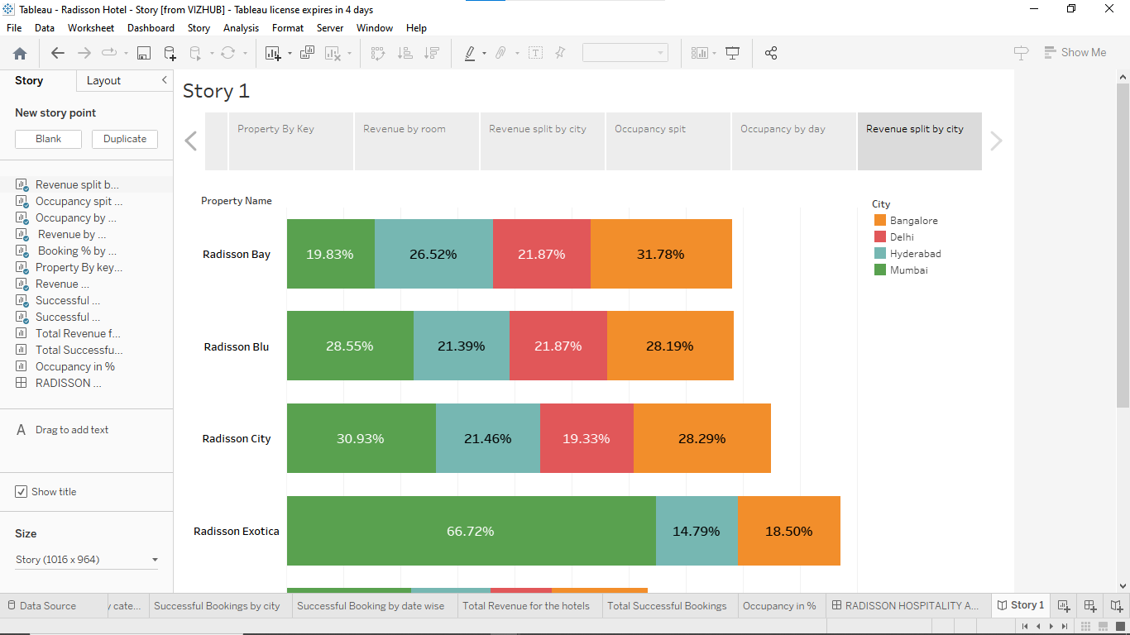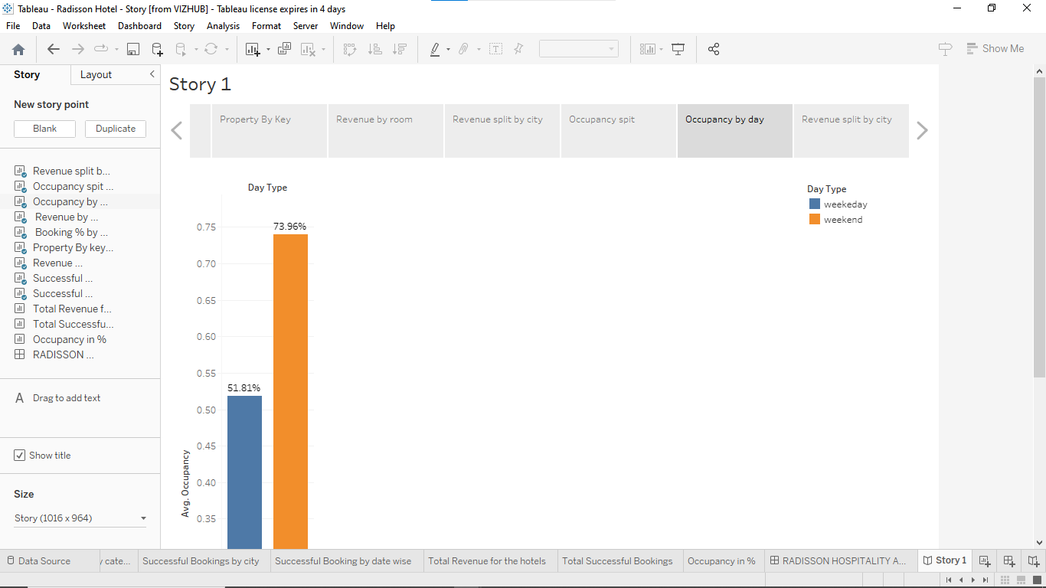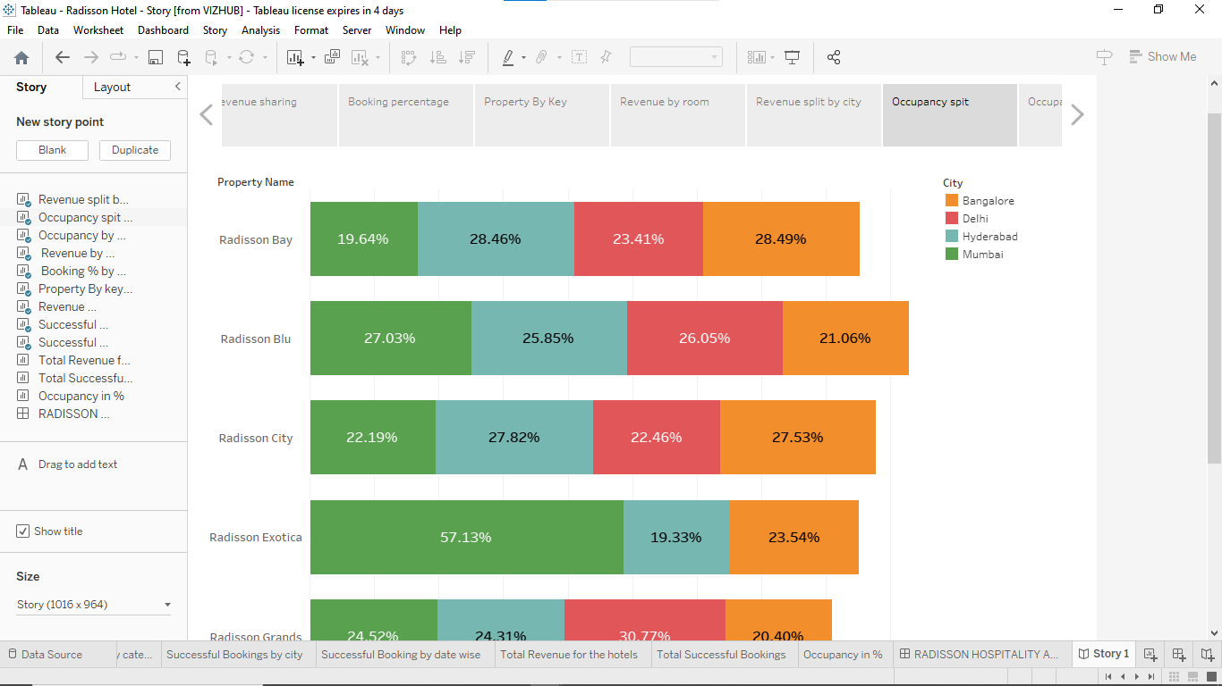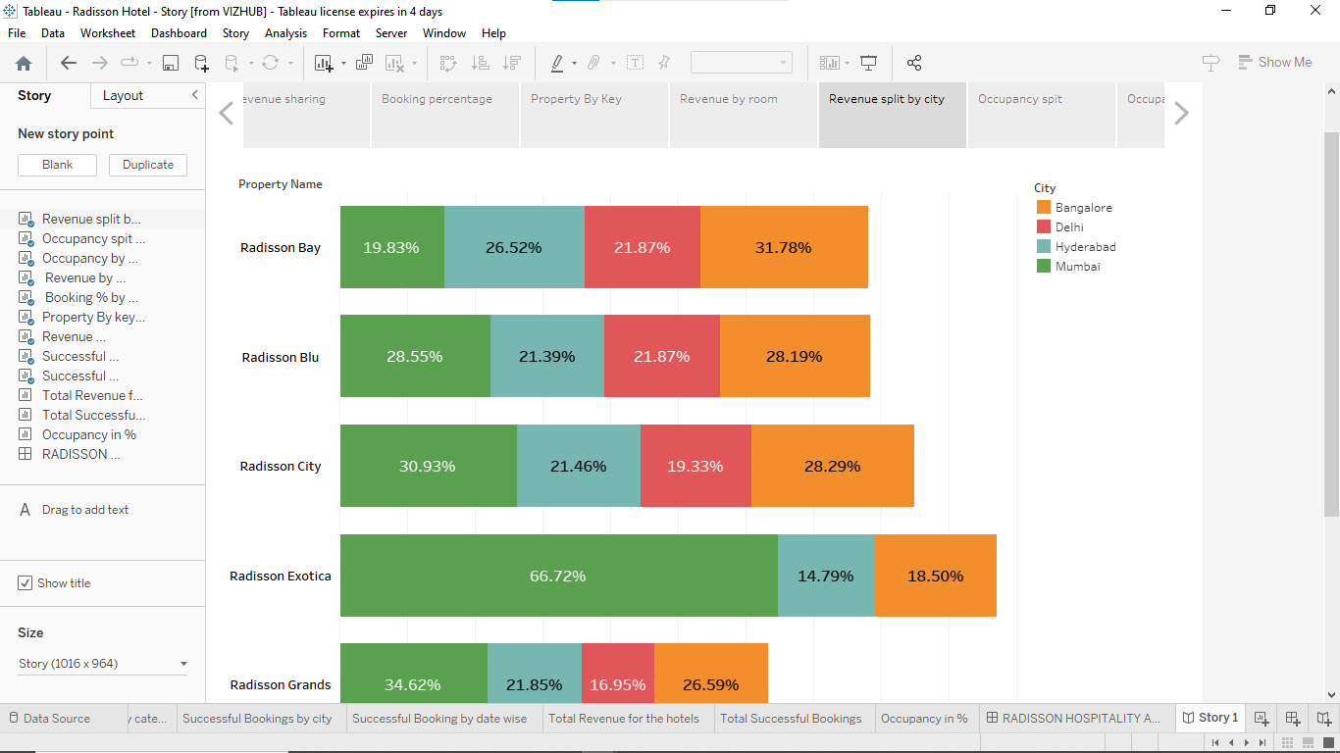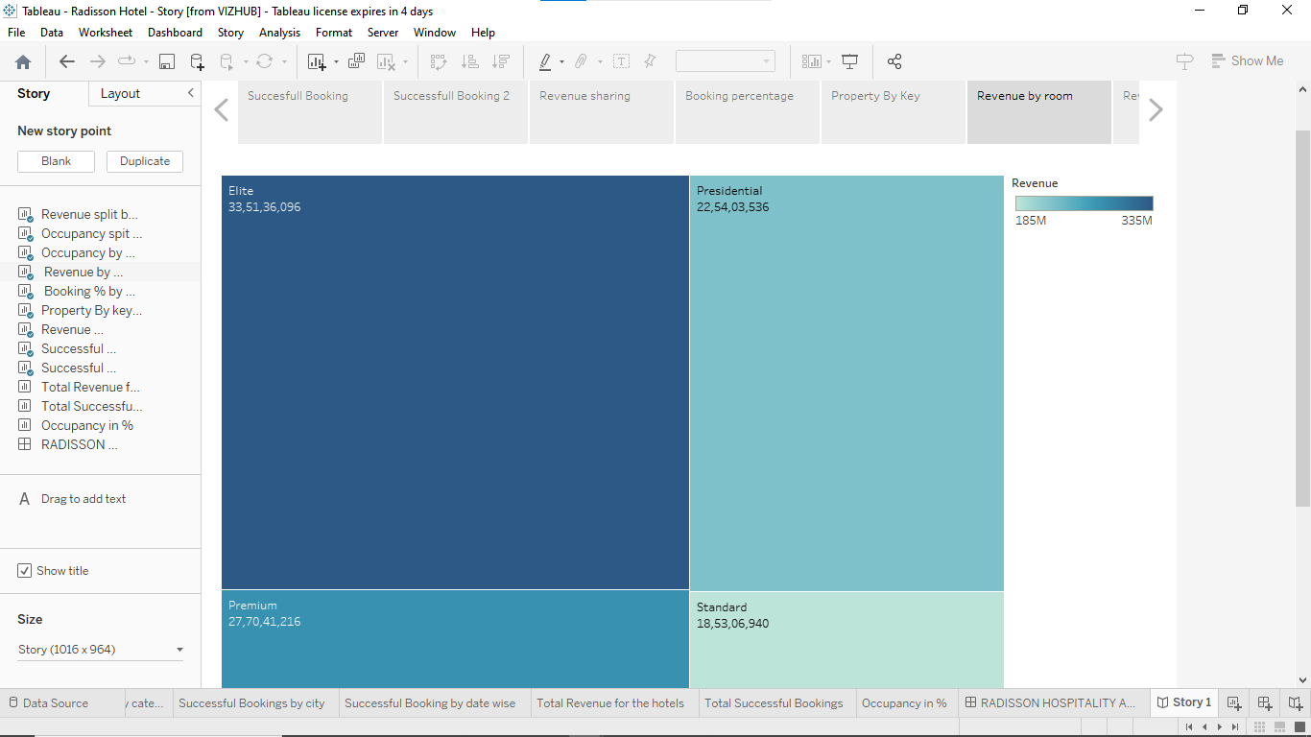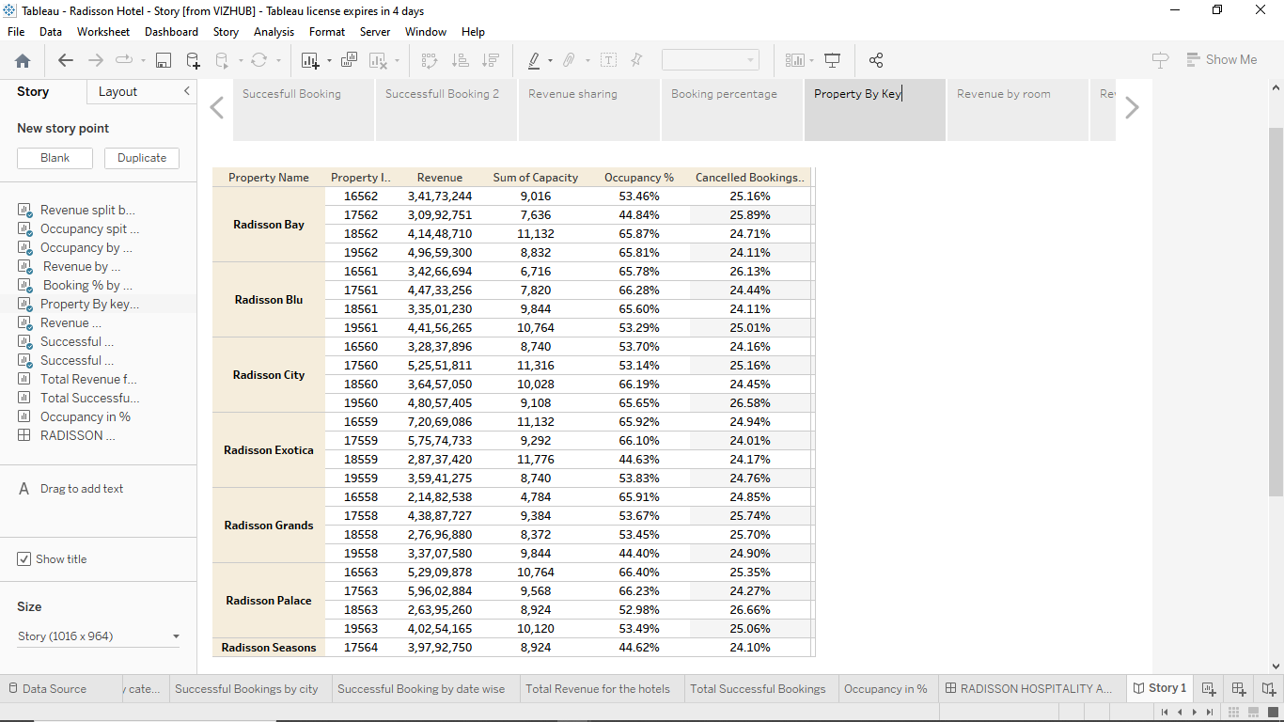

**7.FUTURE SCOPE:**

**Radisson Hotel Analysis.**

**Overall, the future scope of Radisson hotel will depend on its ability to adapt to changing consumer demands and market trends. By leveraging technology, prioritizing sustainability, and diversifying its offerings, the hotel can position itself for future growth and success.**

**8. APPENDIX :**

**SOURCE CODE:**

**DASHBOARD:**

**<div class='tableauPlaceholder' id='viz1682156472088' style='position: relative'><noscript><a href='#'><img alt='RADISSON HOSPITALITY ANALYSIS ' src='https:&#47;&#47;public.tableau.com&#47;static&#47;images&#47;Ra&#47;RadissonHotel-Dashboard&#47;RADISSONHOSPITALITYANALYSIS&#47;1_rss.png' style='border: none' /></a></noscript><object class='tableauViz' style='display:none;'><param name='host_url' value='https%3A%2F%2Fpublic.tableau.com%2F' /> <param name='embed_code_version' value='3' /> <param name='site_root' value='' /><param name='name' value='RadissonHotel-Dashboard&#47;RADISSONHOSPITALITYANALYSIS' /><param name='tabs' value='no' /><param name='toolbar' value='yes' /><param name='static_image' value='https:&#47;&#47;public.tableau.com&#47;static&#47;images&#47;Ra&#47;RadissonHotel-Dashboard&#47;RADISSONHOSPITALITYANALYSIS&#47;1.png' /> <param name='animate_transition' value='yes' /><param name='display_static_image' value='yes' /><param name='display_spinner' value='yes' /><param name='display_overlay' value='yes' /><param name='display_count' value='yes' /><param name='language' value='en-US' /></object></div> <script type='text/javascript'> var divElement = document.getElementById('viz1682156472088'); var vizElement = divElement.getElementsByTagName('object')[0]; if ( divElement.offsetWidth > 800 ) { vizElement.style.width='1320px';vizElement.style.height='4096px';} else if ( divElement.offsetWidth > 500 ) { vizElement.style.width='1320px';vizElement.style.height='4096px';} else { vizElement.style.width='100%';vizElement.style.height='3477px';} var scriptElement = document.createElement('script'); scriptElement.src = 'https://public.tableau.com/javascripts/api/viz_v1.js'; vizElement.parentNode.insertBefore(scriptElement, vizElement); </script>**

**STORY:**

**<div class='tableauPlaceholder' id='viz1682153268156' style='position: relative'><noscript><a href='#'><img alt='Story 1 ' src='https:&#47;&#47;public.tableau.com&#47;static&#47;images&#47;Ra&#47;RadissonHotel-Story&#47;Story1&#47;1_rss.png' style='border: none' /></a></noscript><object class='tableauViz' style='display:none;'><param name='host_url' value='https%3A%2F%2Fpublic.tableau.com%2F' /> <param name='embed_code_version' value='3' /> <param name='site_root' value='' /><param name='name' value='RadissonHotel-Story&#47;Story1' /><param name='tabs' value='no' /><param name='toolbar' value='yes' /><param name='static_image' value='https:&#47;&#47;public.tableau.com&#47;static&#47;images&#47;Ra&#47;RadissonHotel-Story&#47;Story1&#47;1.png' /> <param name='animate_transition' value='yes' /><param name='display_static_image' value='yes' /><param name='display_spinner' value='yes' /><param name='display_overlay' value='yes' /><param name='display_count' value='yes' /><param name='language' value='en-US' /></object></div> <script type='text/javascript'> var divElement = document.getElementById('viz1682153268156'); var vizElement = divElement.getElementsByTagName('object')[0]; vizElement.style.width='1016px';vizElement.style.height='991px'; var scriptElement = document.createElement('script'); scriptElement.src = 'https://public.tableau.com/javascripts/api/viz_v1.js'; vizElement.parentNode.insertBefore(scriptElement, vizElement); </script><div class='tableauPlaceholder' id='viz1682153268156' style='position: relative'><noscript><a href='#'><img alt='Story 1 ' src='https:&#47;&#47;public.tableau.com&#47;static&#47;images&#47;Ra&#47;RadissonHotel-Story&#47;Story1&#47;1_rss.png' style='border: none' /></a></noscript><object class='tableauViz' style='display:none;'><param name='host_url' value='https%3A%2F%2Fpublic.tableau.com%2F' /> <param name='embed_code_version' value='3' /> <param name='site_root' value='' /><param name='name' value='RadissonHotel-Story&#47;Story1' /><param name='tabs' value='no' /><param name='toolbar' value='yes' /><param name='static_image' value='https:&#47;&#47;public.tableau.com&#47;static&#47;images&#47;Ra&#47;RadissonHotel-Story&#47;Story1&#47;1.png' /> <param name='animate_transition' value='yes' /><param name='display_static_image' value='yes' /><param name='display_spinner' value='yes' /><param name='display_overlay' value='yes' /><param name='display_count' value='yes' /><param name='language' value='en-US' /></object></div> <script type='text/javascript'> var divElement = document.getElementById('viz1682153268156'); var vizElement = divElement.getElementsByTagName('object')[0]; vizElement.style.width='1016px';vizElement.style.height='991px'; var scriptElement = document.createElement('script'); scriptElement.src = 'https://public.tableau.com/javascripts/api/viz_v1.js'; vizElement.parentNode.insertBefore(scriptElement, vizElement); </script>**